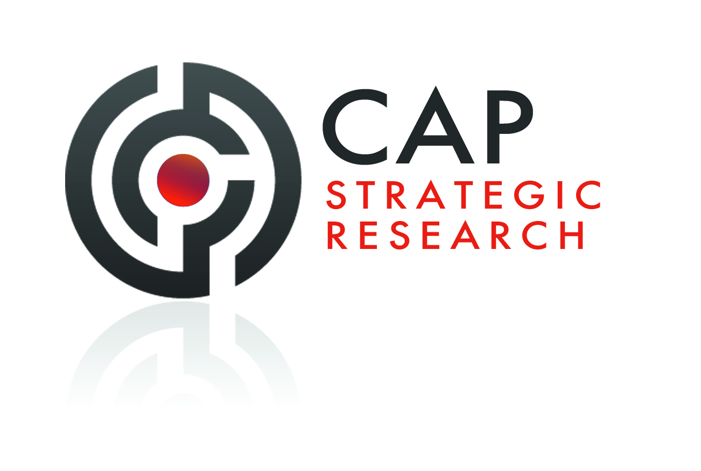
CAP Strategic Research: White Paper 12

Advocacy and Social Media
The New Way to Brand Improvement?

© CAP Strategic Research 2011
Advocacy and Social Media
The New Way to Brand Improvement?

Synopsis
Advocacy is the litmus test on the strength of a brand – it identifies the percentage of customers that have actually recommended a brand by word-of-mouth in the past year. The number of customers – Advocates - that go out of their way to “sell” a brand to other people is the ultimate measure of brand equity. Companies therefore have to devote resources to improving the number and involvement of Advocates of their brands. Most word-of-mouth recommendations still occur offline. Sales and marketing activity CAN drive Advocacy.
Social Media is fast becoming a major element of marketing programmes of corporations, some are now devoting over 50% of their marketing budgets to Social Media.
“We have made digital our priority - it is now 50% of our marketing budget and combines PR with social media” Susan Helstab, Executive VP Marketing at Four Seasons Hotels and Resorts
Research has identified that the majority of Advocacy via Social Media is negative. As such to build brands via Social Media requires careful planning and development.
Advocates form a very important community that can be developed via Social Media to form a very important platform for a company to use for developing customer engagement and feedback, research, concept testing, promotions, PR etc

1. Advocacy - The Best Measure of a Brand
Advocacy is the litmus test on the strength of a brand – it identifies the percentage of customers that have actually recommended a brand by word-of-mouth in the past year. In today’s highly competitive markets customer satisfaction and loyalty are not sufficiently robust measures. It is just not enough to have very satisfied customers to drive business growth; a business needs very satisfied customers who will frequently and consistently speak in favor of the brand, both online and offline. Thus the number of customers that go out of their way to “sell” a brand to other people is the ultimate measure of brand equity. To identify ultimate brand strength therefore we identify the percentage of the current customer base that spontaneously recommend a brand to friends/family/colleagues brand i.e who are “Advocates”. This information is then benchmarked against the competition. NB Advocates form a very important community that can be developed via social media to form a very important platform for a company to use for developing customer engagement and feedback, research, concept testing, promotions, PR etc

The importance of Advocacy is evidenced in the following chart that shows that the best brands achieve high brand scores and significant levels of Advocacy. Apple shows what can done, it is seen as an outstanding brand, it achieves a high Perceived Quality rating of 83.4 but also a massive 42% of customers have spontaneously recommended Apple to their friends/family/colleagues. Lexus is not seen as the best brand but has developed strong engagement with its customer base such that almost a third of them recommend Lexus.
Google is seen as a very strong brand but only 23% of its customers are Advocates

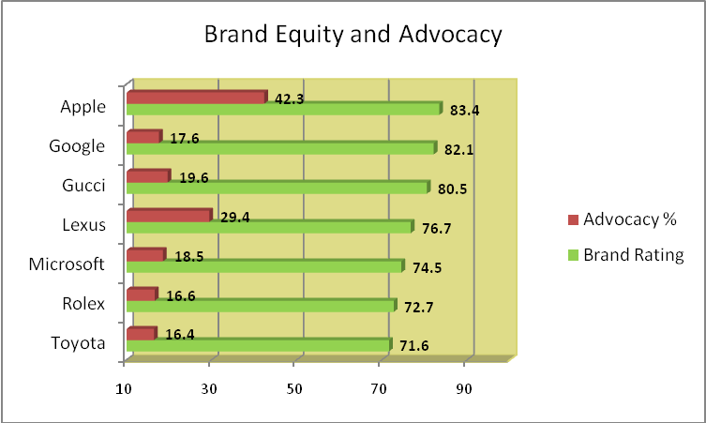

And Advocacy is relevant in all business categories. In some sectors, notably Food & Drink, Media, Beverages and Travel it is vitally important.

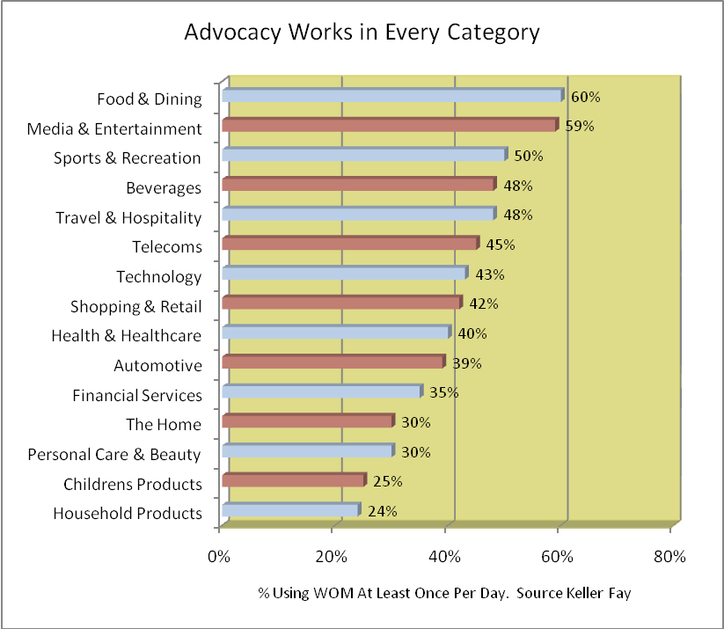
Most word-of-mouth advocacy is positive. A survey by Keller Fay Group revealed that 63% of brand references are positive, seven times the number of negative comments (9%). Positive WOM also carries
more credibility.
Research has also shown that companies can drive Advocacy. The Chart below shows that 1 in 2 brand recommendations are stimulated by external influences. To develop high Advocacy scores obviously requires a company to deliver first class products and services but the marketing and PR departments can play a significant role in this process.
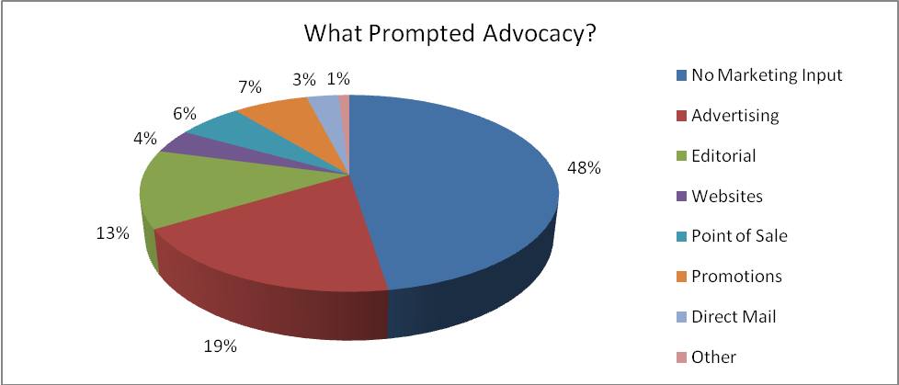

2. Be Careful in Using Social Media To Promote A Brand
Companies now understand the power and relevance of Social Media in helping to build brands and develop close engagement with their customers. Most large organisations now employ Social Media executives within the company and work with specialist external agencies. Massive investments are being made in Social Mdeia and certain companies – Four Seasons, now spend over half their marketing budgets on Social Media.
However it is vital to understand what Social Media can, and cannot do, for a brand. In terms of Advocacy Social Media presents problems. Comments posted on the main Social Media platforms are mainly negative rather than positive. People use Twitter, Facebook etc to complain about a brand rather then advocate it. A survey by Millward Brown found that 31 per cent of people who had used online communities, online contacts and blogs said they received negative brand opinions from them. Positive recommendations about brands were far more likely to come from offline personal contacts, who remain consumers' most widely used source of information when considering purchases.
3. Social Media Doesn’t Drive Purchases
Many surveys have been undertaken to show that people do not use Social Media to buy products. Users turn to social media to seek one another, not brands or products. The reports shows that social media does not, in fact, drive purchases. Fewer than 5% of consumers “regularly turn to these sites for guidance on purchase decisions… and in addition, only 16% of social media users say they are more likely to buy from companies that advertise on social sites. Companies can easily alienate customers by overt use of Social Media to drive purchases or derive sales leads. Users of these sites have a proprietorial attitude towards Twitter, Facebook and resent the intrusion of naked sales promotions.
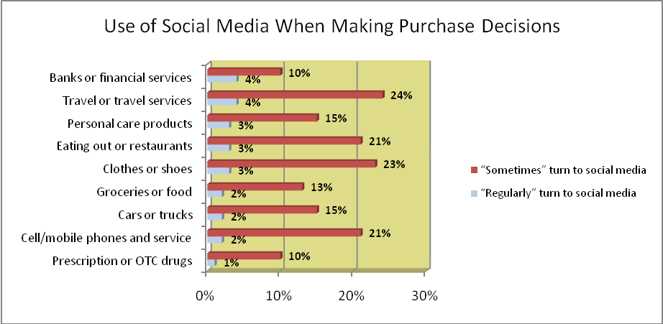

4. Social Media and Customer Engagement
Currently about one-half of companies use social media to promote themselves through social media messaging (56%), monitor trends among their customers (53%), and provide ways for customers to interact with their company (52%). About one-third use social networks to research new product ideas (34%), and about one-fourth advertise on social networks (27%).
However companies are becoming more aware of the dangers of using Social Media to sell products.
Shel Holtz, principal of Holtz Communication + Technology, warns against being too "salesy" when companies engage potential clients in a social media environment.
"I see it as a place to build relationships, but it's not for direct selling. That's not what people want to receive on Facebook. People are there to socialize, and if you can offer value though conversation, you can build relationships with those customers. If you pitch them, they will ignore you, or worse."
Dan McCarthy, chairman and CEO of Network Communications Inc., says
"The Holy Grail for a marketer is positive word of mouth. If you can capture this, it is the highest means of converting prospects to sales, and at the least expense. Social media is one way to supercharge and personalize word of mouth."
Beth Harte of Harte Marketing & Communications also leans towards PR and the social value of social media, arguing that:
"Many see social media as merely a new toolset instead of the enabler that allowed socialness to become part of business processes. Take marketers, for example. They think of social media marketing as doing marketing using social media tools, instead of thinking about it as helping enable social word-of-mouth in marketing."
Companies are now seeing the advantageis of using Social Media to more closely engage with their customers and develop communities which can be used for customer engagement and feedback, research, concept testing, promotions, PR etc. Above all companies are now realising that Social Media, used in appropriate ways, can be very effective in developing Advocacy among customers.
The following table shows how companies currently engage with their customers.
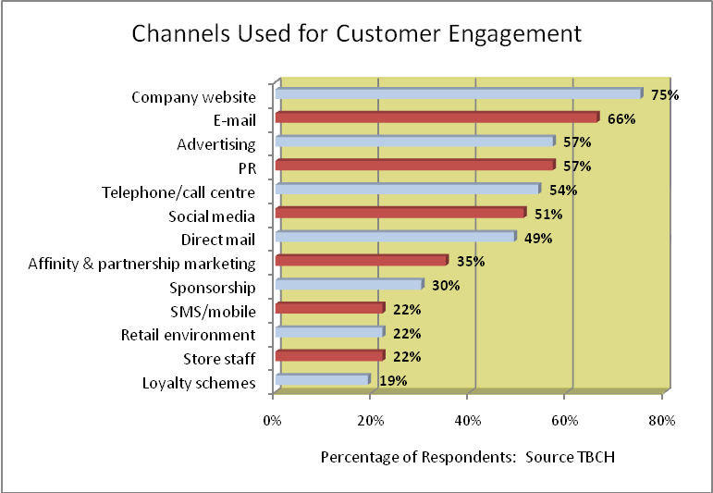
A major way forward is for organisations to develop online communities of their Advocates. These people are “experts” in that they use the brand, like it so much that they actually “sell” it to their friends and colleagues. They are a fabulous audience with which a company should engage. Using Social Media companies can build very important platforms of Adcocates that can be used for customer engagement and feedback, research, concept testing, promotions, PR etc
“Social media is going to remain an integrated part of Air Canada’s overall communication strategy. Through Facebook, Twitter and online forums, we will continue to build an Air Canada community. This is where we tested our new eUpgrade programme and, working with our social media monitoring provider Radian6, we were able to measure sentiment and tweak the programme in response to customer feedback. Using social media we were able to establish a dialogue around potential areas of concern and to make changes to the programme in just a few days after launch to address customer concerns”. Craig Landry VP Marketing, Air Canada
“We’ve reached out and engaged with Tetley’s target audience of housewives aged 25-55 and Tea Folk has attracted 115,000 Facebook fans, of whom 75% are active users participating on the page in the last month. We’ve been asking for ideas around content, merchandising and PR, and it’s great to have them so willing to participate” Anand Gandesha, Tetley Marketing Manager

ABOUT CAP STRATEGIC RESEARCH
CAP Strategic Research (CAP) provides market research services covering China, Hong Kong, Singapore and other Asia-Pacific countries. We have a successful track record of conducting surveys in Asia based on
(i) many years of living and working in the region
(ii) in-depth knowledge and experience of specific industry sectors and
(iii) providing strategic insights and “actionable” recommendations from senior executives who know your industry, have extensive international experience and - very importantly - have an “understanding of business”. We have over 25 years experience of conducting research for clients based in China, Asia-Pacific Europe and the US. With offices in China, Hong Kong and Singapore we are ideally placed to meet your research needs in Asia-Pacific.

For more information please contact:
Roger Thomas, CAP Strategic Research
Tel: +852 37508640
Email: roger@capstrategicresearch.com
Or
Keith Kong, CAP Strategic Research
Tel: +852 37508638
Email: keith@capstrategicresearch.com
Address: 1501-08 Millennium City 5, 418 Kwun Tong Road, Kwun Tong, Kowloon, Hong Kong.

